Brian Bauman

**CSC 421 - Assignment 4**

1. Pinnochio would be incorrect. There exist scenarios where this greedy choice would split the graph in such a way that the optimal solution is lost. An example is below:

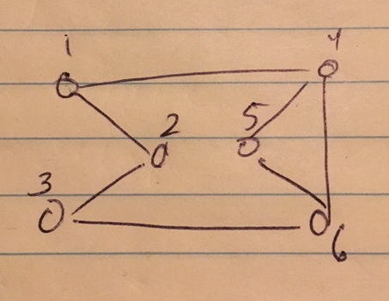

If you select node 5 first (minimum degree of 2), you end up with a suboptimal solution.

2. Starting at s:

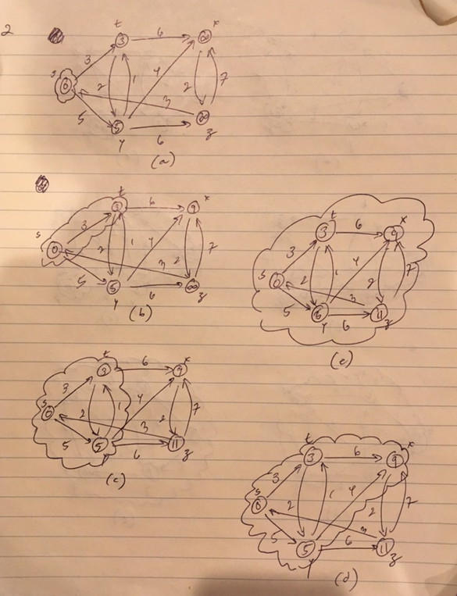

Starting at z:

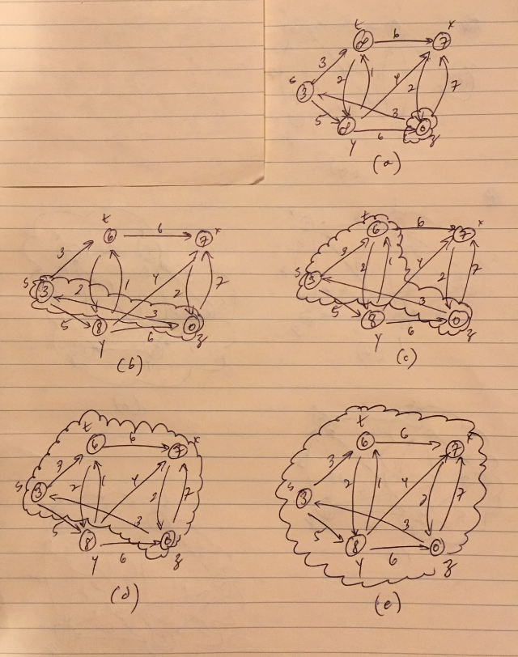

3. This algorithm will not always produce a minimum spanning tree. Imagine the graph below, initially split as shown. Because the recursive step that will split nodes b and c must rejoin them with the edge of weight 2, this method misses the optimal solution a -(1)-> b -(1)-> c.

